

ASSET VERIFICATION AND RECORDING TOOL KIT


Plot 31, Bukoto Street
P.O Box 7657, Kampala, Uganda
+256 (0) 39 2000216/0772525235
email: cpa@cpa.ug

www.cpa.com

August to September 2026

VERIFICATION DETAILS

NAME OF THE REGION: | NOTHERN REGION
SUB-REGION: | LANGO-SUB REGION
Name of Local Government | DOKOLO DISTRICT LOCAL GOVERNMENT
VERIFIER PARTICULARS
Full name | AGANYO MERCY
Contact/ email and Telephone | 0786551826  mercyaganyo22@gmail.com
Supervisor/ Sub team leader
Name | MR.DENIS
Contact | 0779622063
Date of submission | 29TH AUGUST 2026

HEALTH CENTRES
INFORMANT INTERVIEW/DISCUSSION GUIDE (INCHARGE OR RESPONSIBLE PERSON)

Name of Health Centre: AWELO HEALTH CENTER III

1a | Does the Facility have a record of all assets provided under UgIFT.  (Obtain a record and verify if it has the costs and numbers supplied | YES
1b | If Not ask how many were supplied and when.

2 | How does this facility Maintain (repair/service/replace) the assets provided under Ugift

AWELO Health center III uses the Primary Health Care fund to service and repair the damaged equipment.

3 | Does the facility take regular record about functionality/ or breakdown of the assets provided?

Yes the facility always takes regular record of the functionality of the equipment, incase of any breakdown ,it is recorded for better decision making.

4 | How has the UgIFT support helped in service delivery in the area, any issues, challenges and any recommendations for better program implementation.

The UGIFT support has improved service delivery by providing the equipment that the health facility lacked and it has equally improved the privacy of patients.
It has increased the admisssions of patients because of the wards constructed.

Issues / challenges: Some of the equipment delivered were not assembled like the delivery bed which needs experts to assemble it.

Recommendations: UGIFT should extend its services to the construction of staff and construction of the kitchen for patients
UGIFT should also assist in supplying computers to the health facility.

PROCEED TO VERIFICATION AFTER THIS DISCUSSION

Health Centre checklist

NAME OF LG: DOKOLO DISTRICT LOCAL GOVERNMRNT NAME OF HEALTH FACILITY: AWELO HEALTH CENTER III

Equipment/ Item | Department | Asset Number | Item  Description | Life in Months | Tag Number ( engrave no.) | Date Of Purchase | Date Placed In Service | Recoverable cost | Cost | Acc Dep Cost | Net Book Value | Ytd Deprn | Equipment status | Remarks
B.P. Machine, Digital(2) | MCH  OPD |  | Digital | 60 | Not engraved | 21st May 2025 | July 2025 |  |  |  |  |  | Functional | Good working condition
B.P. Machine (Aneroid wall mounted)(2) | IPD  OPD |  | Manual | 60 | Not engraved | 21st May 2025 | July 2025 |  |  |  |  |  | Functional | Good condition
Autoclave 20 Liters.,Duo Operated (1) | MCH |  | Plastic | 60 | Not engraved | 21st May 2025 | July 2025 |  |  |  |  |  | Functional | Good condition
Bowl, Kick (1) | MCH |  | Metallic | 70 | Not engraved | 21st May 2025 | July 2025 |  |  |  |  |  | Functional | Good working condition
u
Bowl Stand (2) | MCH |  | Metallic | 60 | Not engraved | 21st May 2025 | July 2025 |  |  |  |  |  | Functional | Good working condition and 1 is still in the store
Counting chamber Neubauer- Improved (2) | IPD  MCH |  | Plastic | 36 | Not engraved | 21st May 2025 | July 2025 |  |  |  |  |  | Functional | Good working condition
Cupboard Steel, Lockable (2) | OPD  IPD |  | Metallic | 70 | Not engraved | 21st May 2025 | July 2025 |  |  |  |  |  | Functional | Good condition
Drip Stand(8) | IPD  MCH |  | Metallic | 60 | Not engraved | 21st May 2025 | July 2025 |  |  |  |  |  | Functional | Good condition
ESR Stand (1) | Store |  | Glass in nature | 36 | Not engraved | 21st May 2025 | July 2025 |  |  |  |  |  | Non-functional | Still in the store
Examination Couch (2) | OPD |  | Metallic with mattress | 65 | Not engraved | 21st May 2025 | July 2025 |  |  |  |  |  | Functional | 1 is in a good working condition and the other is still in the store
Examination light,LED (2) | MCH |  | Plastic | 60 | Not engraved | 21st May 2025 | July 2025 |  |  |  |  |  | Functional | Good condition
Glucometer (1) | LAB |  | Digital | 36 | Not engraved | 21st May 2025 | July 2025 |  |  |  |  |  | Functional | Good condition
Haemoglobin Meter, Digital (2) | Store |  | Digital | 60 | Not engraved | 21st May 2025 | July 2025 |  |  |  |  |  | Non-functional because the strips are not matching the machine | Still kept in the store
Height Meter (1) | OPD |  | Metallic | 60 | Not engraved | 21st May 2025 | July 2025 |  |  |  |  |  | functional | Good condition
Instrument Trolley (2) | IPD  MCH |  | Metallic | 60 | Not engraved | 21st May 2025 | July 2025 |  |  |  |  |  | Functional | Good condition
Microscope Binocular (1) | LAB |  | Metallic | 60 | Not engraved | 21st May 2025 | July 2025 |  |  |  |  |  | Functional | Poor condition, it cannot see parasites clearly
Otoscope (1) | OPD |  | Metallic | 60 | Not engraved | 21st May 2025 | July 2025 |  |  |  |  |  | Functional | Good condition
Patient Screen (4) | OPD  MCH |  | Digital | 60 | Not engraved | 21st May 2025 | July 2025 |  |  |  |  |  | Functional | Good condition
Patient Trolley (1) | IPD |  | Metallic | 60 | Not engraved | 21ST May 2025 | July 2025 |  |  |  |  |  | Functional | Good condition
Refrigerator, Basic (1) | LAB |  | Metallic | 70 | Not engraved | 21st May 2025 | July 2025 |  |  |  |  |  | Functional | Good condition
Stethoscope (4) | IPD  OPD  MCH |  | Manual | 60 | Not engraved | 21st May 2025 | July 2025 |  |  |  |  |  | Functional | Good condition
Stop Watch (2) | LAB |  | Metallic | 40 | Not engraved | 21st May 2025 | July 2025 |  |  |  |  |  | Functional | Good condition
Stretcher (1) | MCH |  | Metallic with leather | 60 | Not engraved | 21st May 2025 | July 2025 |  |  |  |  |  | Functional | Good working condition
Stove, Gas (1) | MCH |  | Metallic | 70 | Not engraved | 21st May 2025 | July 2025 |  |  |  |  |  | Functional | Good condition
Weighing Scale with Height Meter, Adult (2) | MCH  OPD |  | Metallic | 60 | Not engraved | 21st May 2025 | May 2025 |  |  |  |  |  | Functional | Good condition
Weighing Scale, Infant (2) | MCH |  | Plastic | 60 | Not engraved | 21st May 2025 | July 2025 |  |  |  |  |  | Functional | Good condition
Weighing Scale, Toddler | - | - | - | - | - | - | - | - | - | - | - | - | - | -
Wheel Chair (1) | MCH |  | Metallic with leather | 60 | Not engraved | 21st May 2025 | July 2025 |  |  |  |  |  | Functional | Good condition
Audio Visual Equipment | - | - | - | - | - | - | - | - | - | - | - | - | - | -
Medical Waste Bin (6) | MCH  IPD  OPD |  | Plastic | 60 | Not engraved | 21st May 2025 | July 2025 |  |  |  |  |  | Functional | Good condition
Wall Clock (4) | MCH  OPD |  | Metallic | 36 | Not engraved | 21st May 2025 | July 2025 |  |  |  |  |  | Functional | Good working condition and 2 are still in the store
Diagnostic Equipment Set for MCH (2) | MCH |  | Stainless steel | 60 | Not engraved | 21st May 2025 | July 2025 |  |  |  |  |  | Functional | Good condition
Diagnostic Equipment Set for OPD (2) | OPD |  | Stainless steel | 60 | Not engraved | 21st May 2025 | July 2025 |  |  |  |  |  | Functional | Good condition
Glassware Set, Laboratory, Basic (2) | LAB |  | Glass in nature | 36 | Not engraved | 21st May 2025 | July 2025 |  |  |  |  |  | Functional | Good condition
Hollow Ware Set, Treatment (3) | Store |  | Metallic | 60 | Not engraved | 21st May 2025 | July 2025 |  |  |  |  |  | Non-functional | Good condition
Instrument Set, Dressing (1) | IPD |  | Metallic | 60 | Not engraved | 21st May 2025 | July 2025 |  |  |  |  |  | Functional | Good condition
Instrument Set, Basic ENT (3) | Store |  | Stainless steel | 60 | Not engraved | 21st May 2025 | July 2025 |  |  |  |  |  | Non-functional | Still in store
Instrument Set, Suture | - | - | - | - | - | - | - | - | - | - | - | - | -- | -
Pulse Oximeter, Hand held (2) | MCH  IPD |  | Plastic | 60 | Not engraved | 21st May 2025 | July 2025 |  |  |  |  |  | Functional | Good condition
Bed, Adult Patient with Mattress (10) | MCH IPD |  | Metallic with mattress | 90 | Not engraved | 21st May 2025 | July 2025 |  |  |  |  |  | Functional | Good condition
Bed, Pediatric Patient, With Mattress (5) | IPD |  | Metallic with mattress | 90 | Not engraved | 21st May 2025 | July 2025 |  |  |  |  |  | Functional | Good condition.
Bedside Locker (3) | MCH  OPD |  | Metallic | 60 | Not engraved | 21st May 2025 | July 2025 |  |  |  |  |  | Functional | Good working condition
Cupboard, Instrument (1) | IPD |  | Metallic | 70 | Not engraved | 21st May 2025 | July 2025 |  |  |  |  |  | Functional | Good condition
Delivery Bed, Hydraulic Manual (1) | MCH |  | Metallic with mattress | 70 | Not engraved | 21st May 2025 | July 2025 |  |  |  |  |  | Functional | Good condition
Oxygen Therapy Apparatus, Mininum 45L cylinder (2) | MCH  IPD |  | Metallic | 70 | Not engraved | 21st may 2025 | July 2025 |  |  |  |  |  | Functional | Good working condition
Resuscitator Manual, Infant, with all Mask sizes (2) | MCH |  | Plastic | 60 | Not engraved | 21st May 2025 | July 2025 |  |  |  |  |  | Functional | Good condition
Resuscitator Manual, Adult, with all mask sizes (2) | Store |  | Plastic | 60 | Not engraved | 21st May 2025 | July 2025 |  |  |  |  |  | Functional | Good working condition
Suction Apparatus, (Electric) (2) | MCH |  | Electrical | 60 | Not engraved | 21st May 2025 | July 2025 |  |  |  |  |  | Functional | Good condition and 1 is still in the store.
Nebulizer, Ultrasonic (1) | Store |  | Electrical | 60 | Not engraved | 21st May 2025 | July 2025 |  |  |  |  |  | Non-functional | Still kept in the store
Oxygen Concentrator, Duo Flow (4) | MCH |  | Electrical and plastic | 50 | Not engraved | 21st May 2025 | July 2025 |  |  |  |  |  | Functional | Good conditional and 3 are still in the store
Bench (4) | MCH  OPD |  | Wooden | 90 | Not engraved | 21swt May 2025 | July 2025 |  |  |  |  |  | Functional | Good condition
Disinfection Buckets (2) | MCH |  | Plastic | 60 | Not engraved | 21st May 2025 | July 2025 |  |  |  |  |  | Functional | Good condition
Baby Cot (5) | MCH |  | Plastic | 60 | Not engraved | 21st May 2025 | July 2025 |  |  |  |  |  | Functional | Good condition
Diagnostic Equipment Set for Ward (3) | IPD |  | Metallic | 70 | Not engraved | 21st May 2025 | July 2025 |  |  |  |  |  | Functional | Good condition
Hollow Ware Set, Ward (3) | IPD |  | Stainless steel | 70 | Not engraved | 21st May 2025 | July 2025 |  |  |  |  |  | Functional | Good condition
Instrument Set, Delivery (3) | MCH |  | Stainless steel | 70 | Not engraved | 21st May 2025 | July 2025 |  |  |  |  |  | Functional | Good condition
Instrument Set, Stitch Removing (3) | MCH |  | Metallic | 70 | Not engraved | 21st May 2025 | July 2025 |  |  |  |  |  | Functional | Good condition
MVA Kit (4) | MCH |  | Plastic | 60 | Not engraved | 21st May 2025 | July 2025 |  |  |  |  |  | Functional | Good condition
Stool, Laboratory (1) | LAB |  | Metallic with leather | 60 | Not engraved | 21st May 2025 | July 2025 |  |  |  |  |  | Functional | Good condition
Penguin Sucker (3) | MCH |  | Rubber | 40 | Not engraved | 21st May 2025 | July 2025 |  |  |  |  |  | Functional | Good condition
Fetoscope, Dopplar (2) | MCH |  | Metallic | 60 | Not engraved | 21st May 2025 | July 2025 |  |  |  |  |  | Functional | Good condition and 1 is still in the store
Bubble CPAP | - | - | - | - | - | - | - | - | - | - | - | - | - | -
Centrifuge (Electric) (2) | LAB |  | Electrical | 60 | Not engraved | 21st May 2025 | July 2025 |  |  |  |  |  | Functional | Good condition
Kangaroo Mother Care Chair (1) | MCH |  | Metallic with leather | 60 | Not engraved | 21st May 2025 | July 2025 |  |  |  |  |  | Functional | Good condition
Radiant Infant Warmer | - | - | - | - | - | - | - | - | - | - | - | - | - | -
Haemoglobin Meter, Sahli | - | - | - | - | - | - | - | - | - | - | - | - | - | -
Delivery Bed (1) | MCH |  | Metallic with mattress | 90 | Not engraved | 21st May 2025 | July 2025 |  |  |  |  |  | Functional | Good condition
Examination light | - | - | - | - | - | - | - | - | - | - | - | - | - | -
Instrument set, ENT Basic for HCIII (3) | IPD |  | Stainless steel | 70 | Not engraved | 21st May 2025 | July 2025 |  |  |  |  |  | Functional | Good condition
Bag Valve mask (Ambu Bag), Neonatal (1) | MCH |  | Plastic | 60 | Not engraved | 21st May 2025 | July 2025 |  |  |  |  |  | Functional | Good condition
Incubator | - | - | - | - | - | - | - | - | - | - | - | - | - | -
Office Chair (4) | OPD |  | Metallic with leather | 90 | Not engraved | 21st May 2025 | July 2025 |  |  |  |  |  | Functional | Good condition
Desk (10) | OPD  MCH |  | Wooden with metallic stands | 70 | Not engraved | 21st May 2025 | July 2025 |  |  |  |  |  | Functional | Good condition
Filing Cabinet (2) | MCH  OPD |  | Metallic | 90 | Not engraved | 21st May 2025 | July 2025 |  |  |  |  |  | Functional | Good condition
Non Residential Buildings (2) | Health |  | Concrete building | 200 | Not engraved | 21st May 2025 | July 2025 |  |  |  |  |  | Functional | Good condition
Toilets
Staff kitchen | Health |  | Concrete building | 200 | Not engraved | 21st May 2025 | July 2025 |  |  |  |  |  | Functional | Good state
Residential Buildings (2) 1 ward and 2 staff twin houses | Health |  | Concrete Block building | 600 | Not engraved | 21st May 2025 | July 2025 |  |  |  |  |  | Functional | Good state

SAMPLE PICTURES OF AWELO HEALTH CENTER III

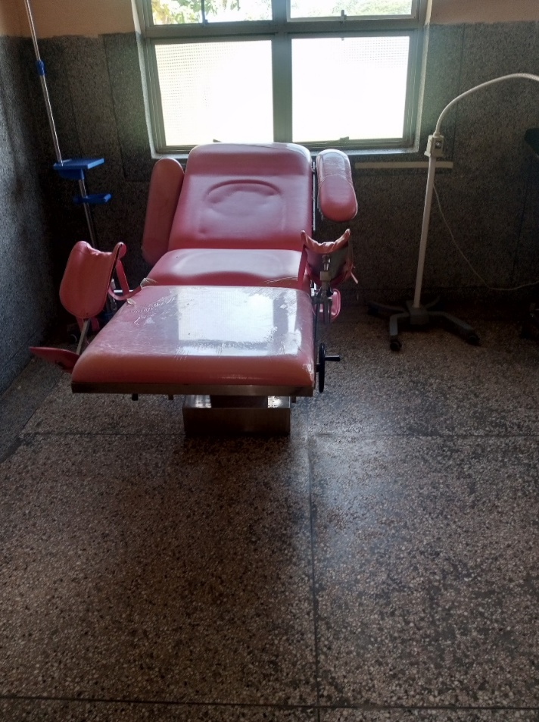

Delivery bed, Hydraulic manual

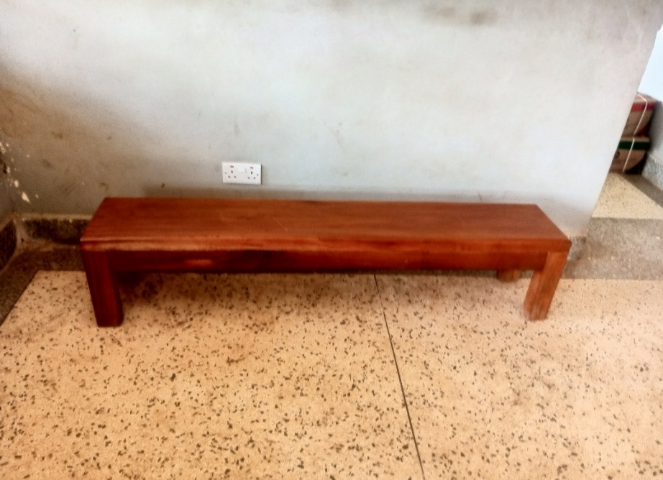

Sample of a bench

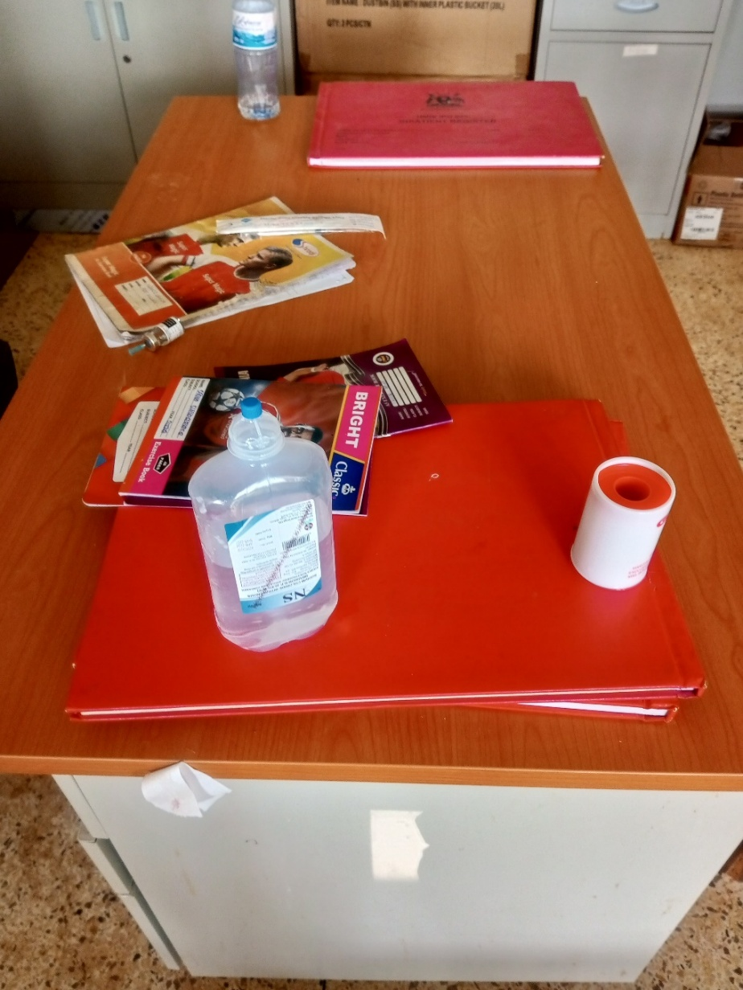

Sample of a desk

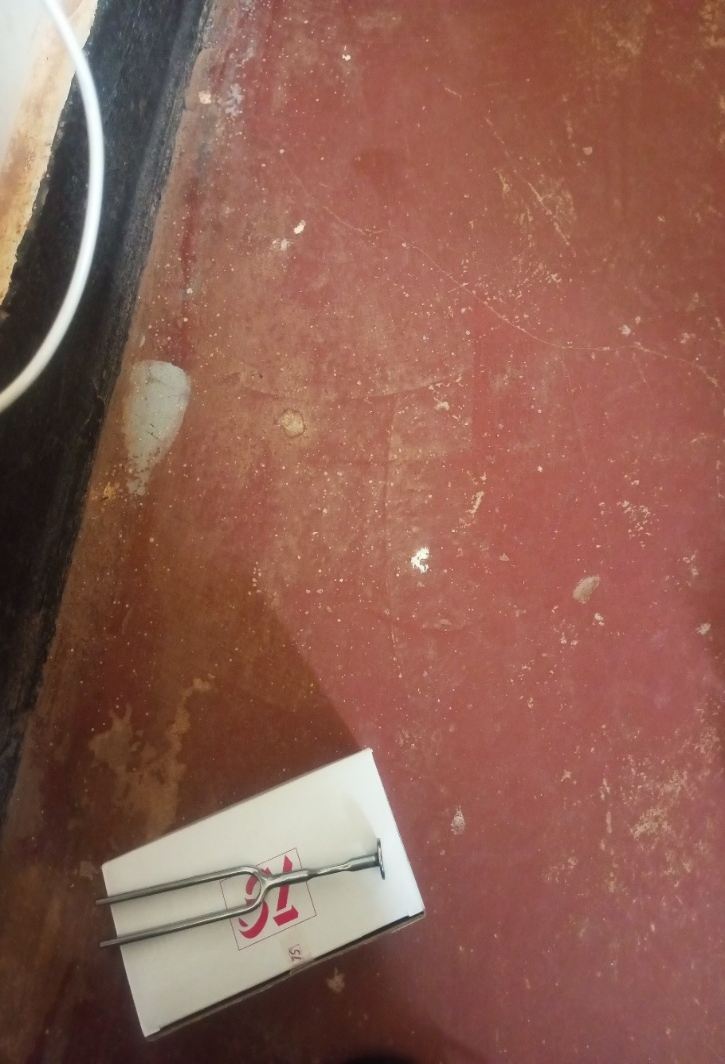

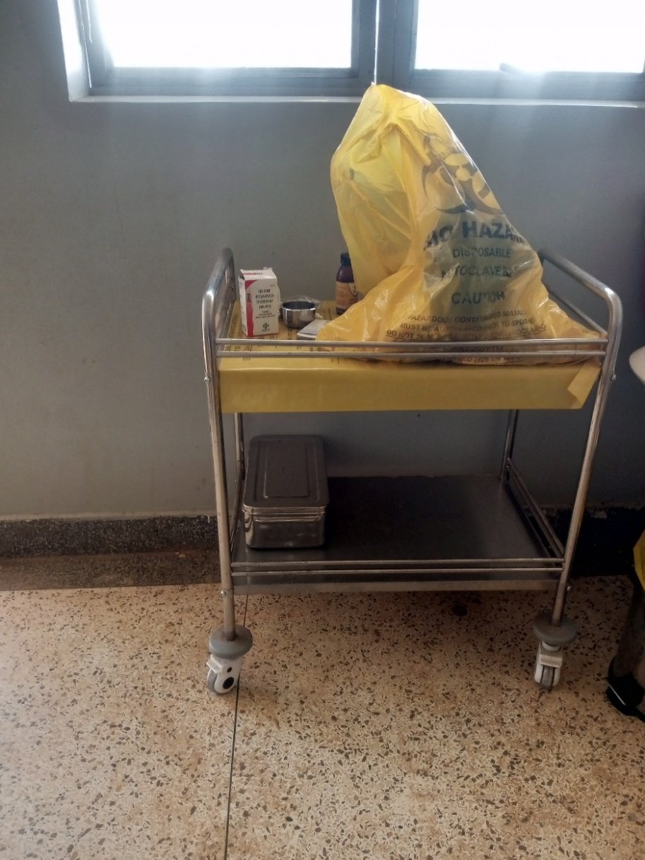

Instrument trolley

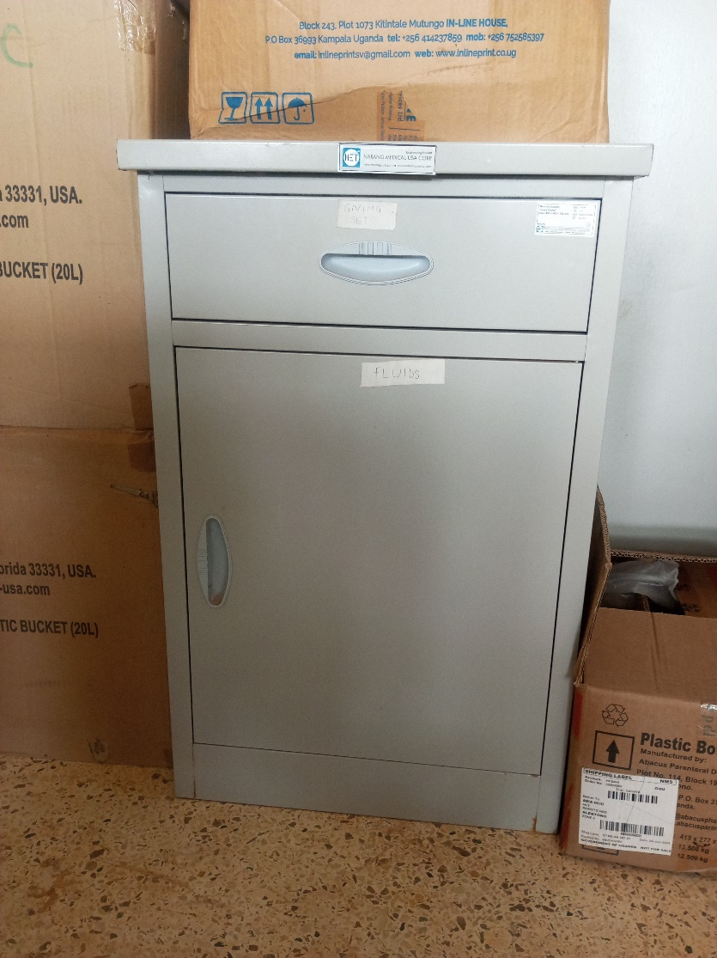

Sample picture of a filing cabinet

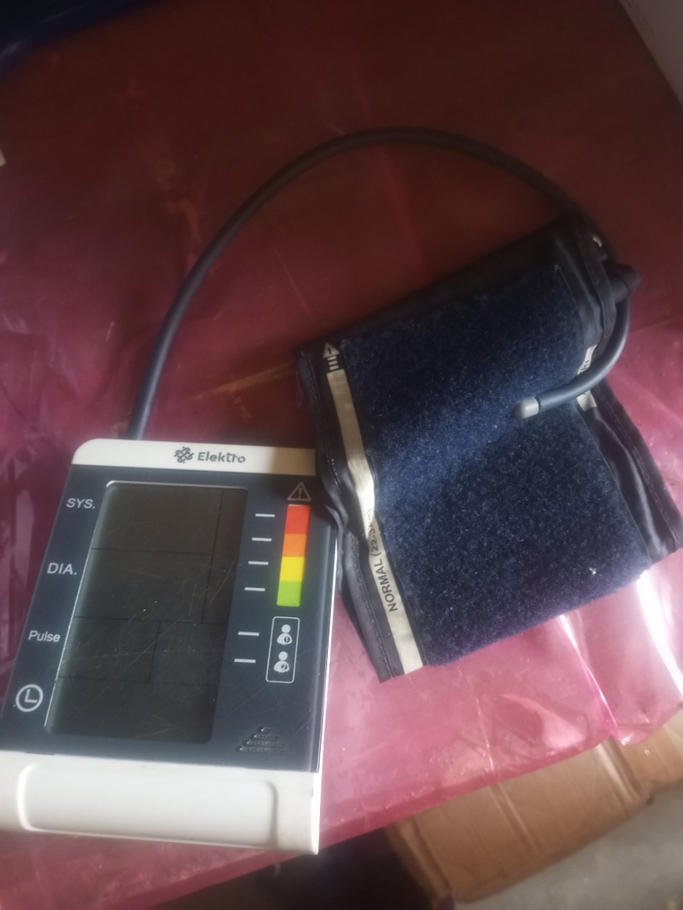

Sample picture of a B.P machine

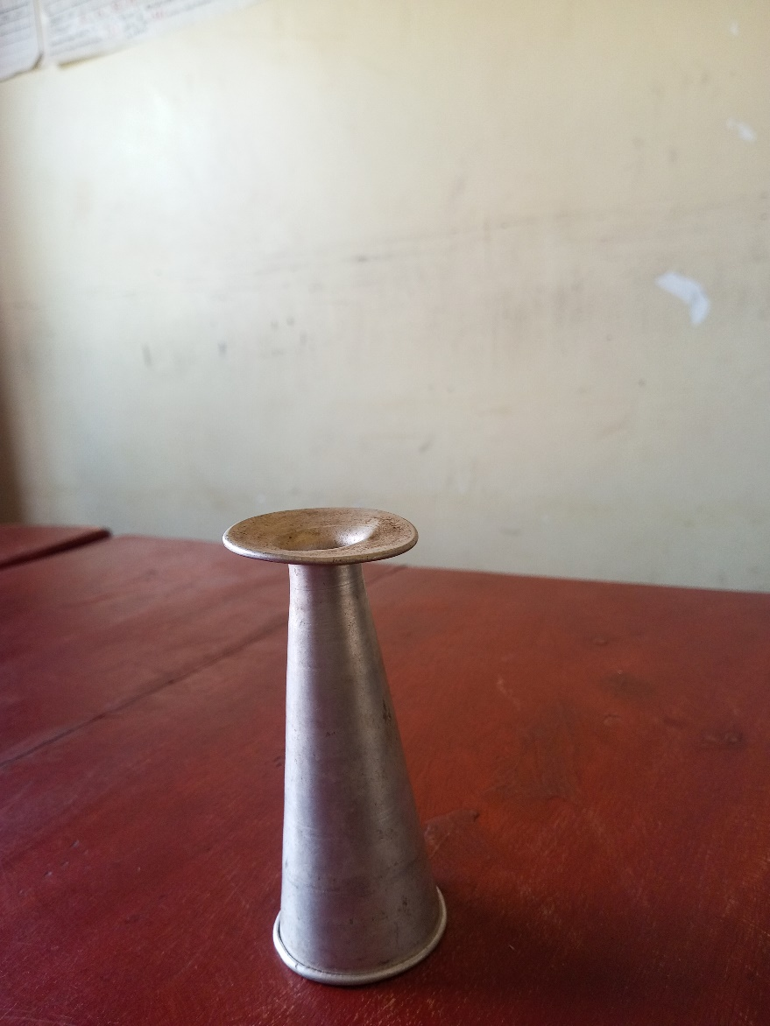

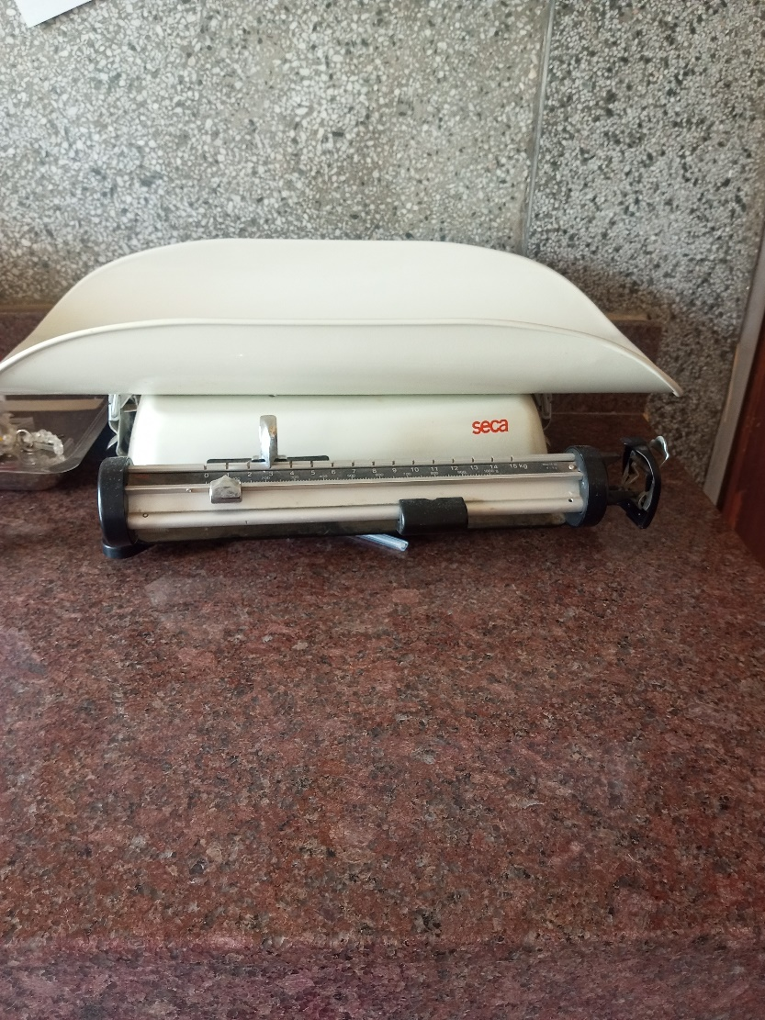

Sample picture of weighing scale, infant

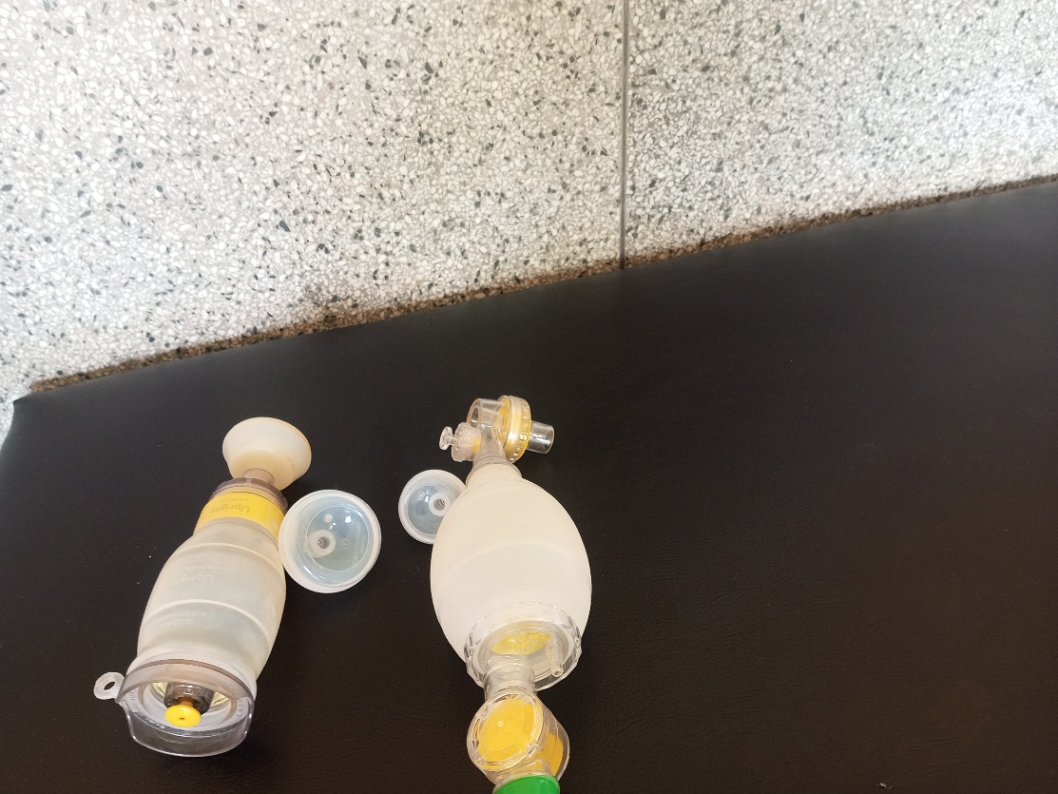

Sample picture of a penguin sucker

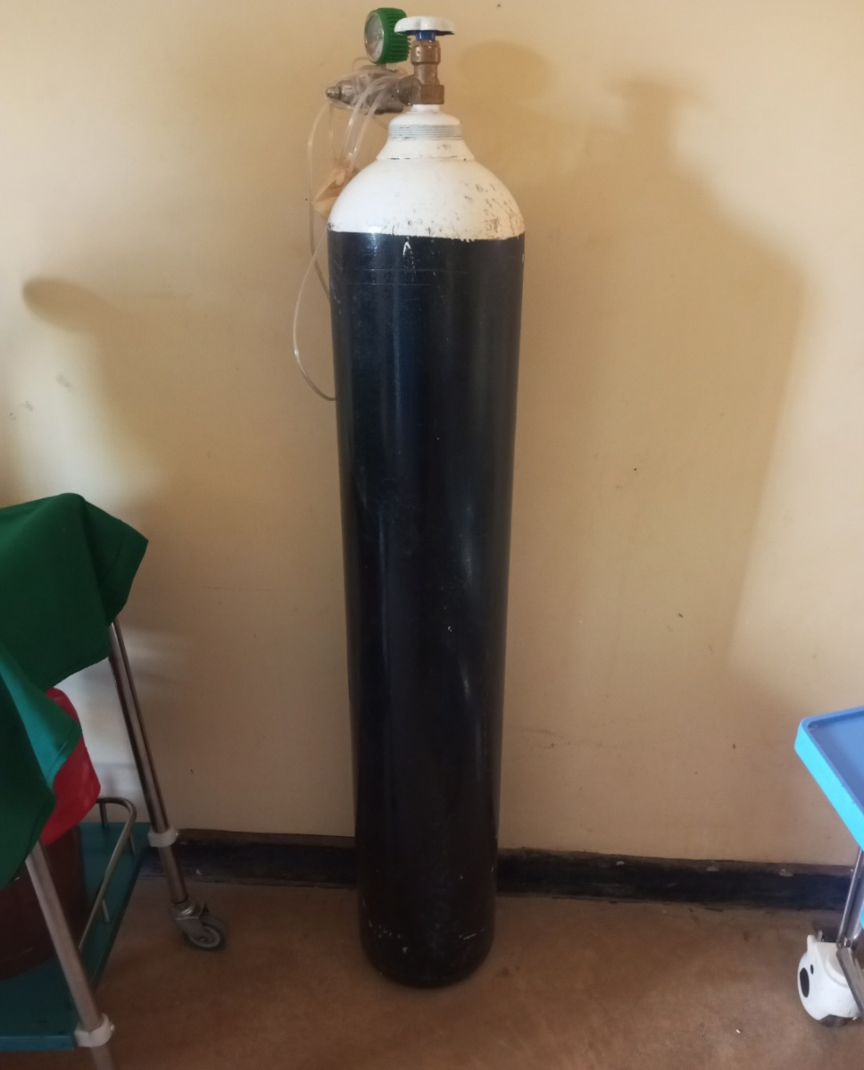

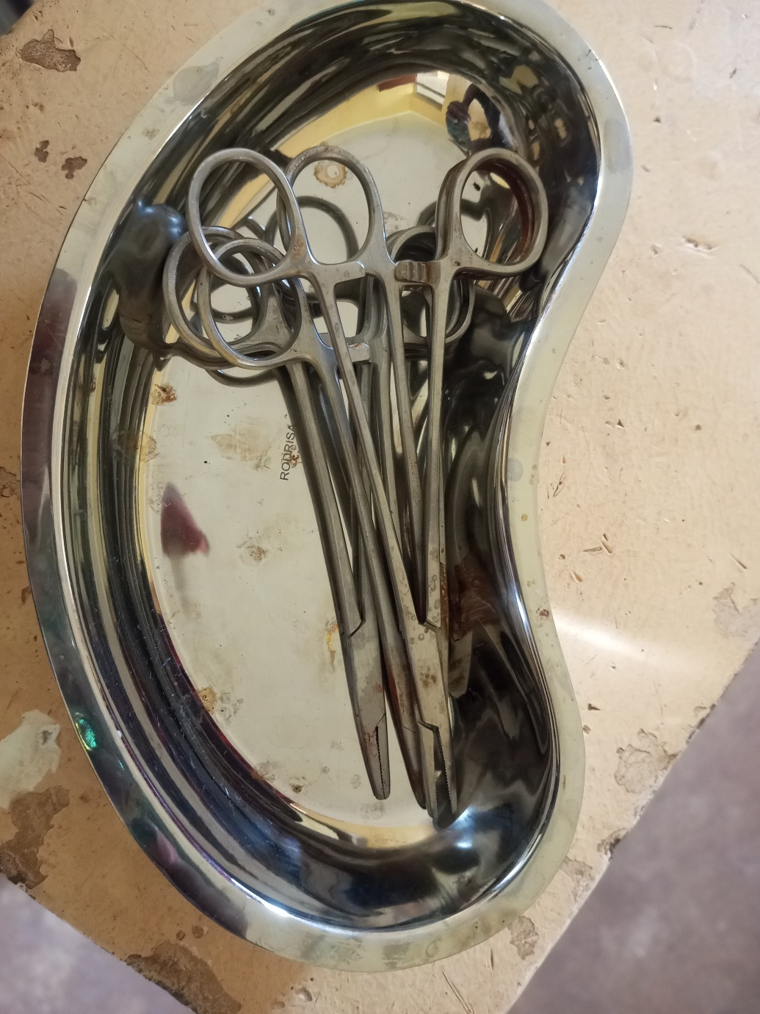

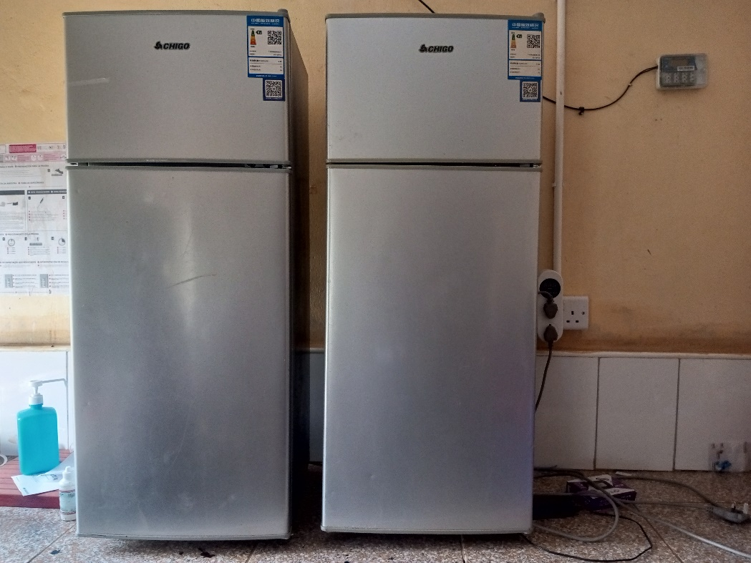

Refrigerator Basic

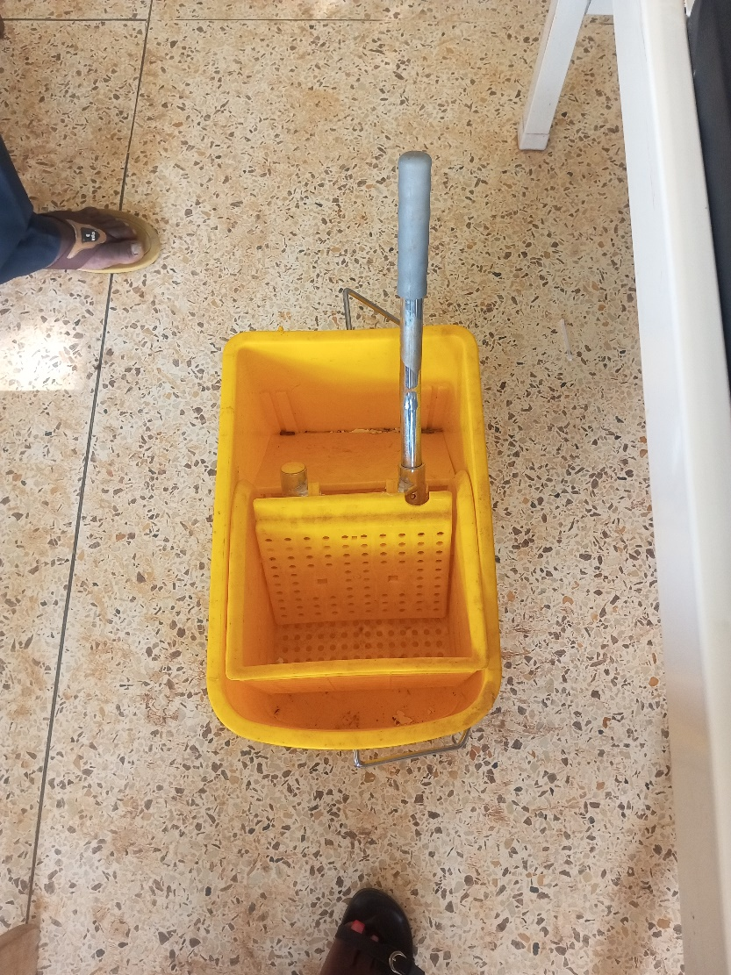

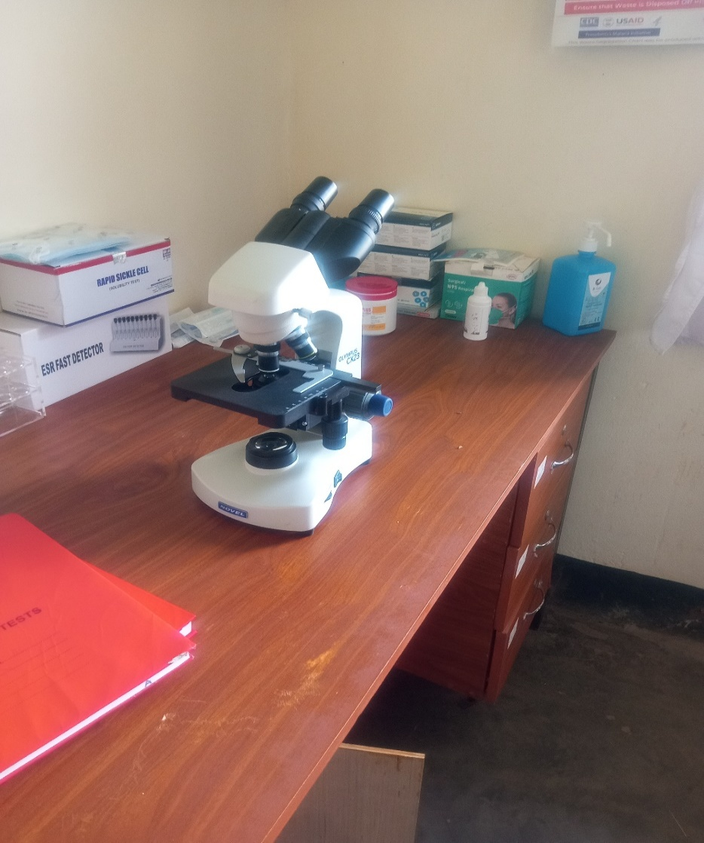

Microscope

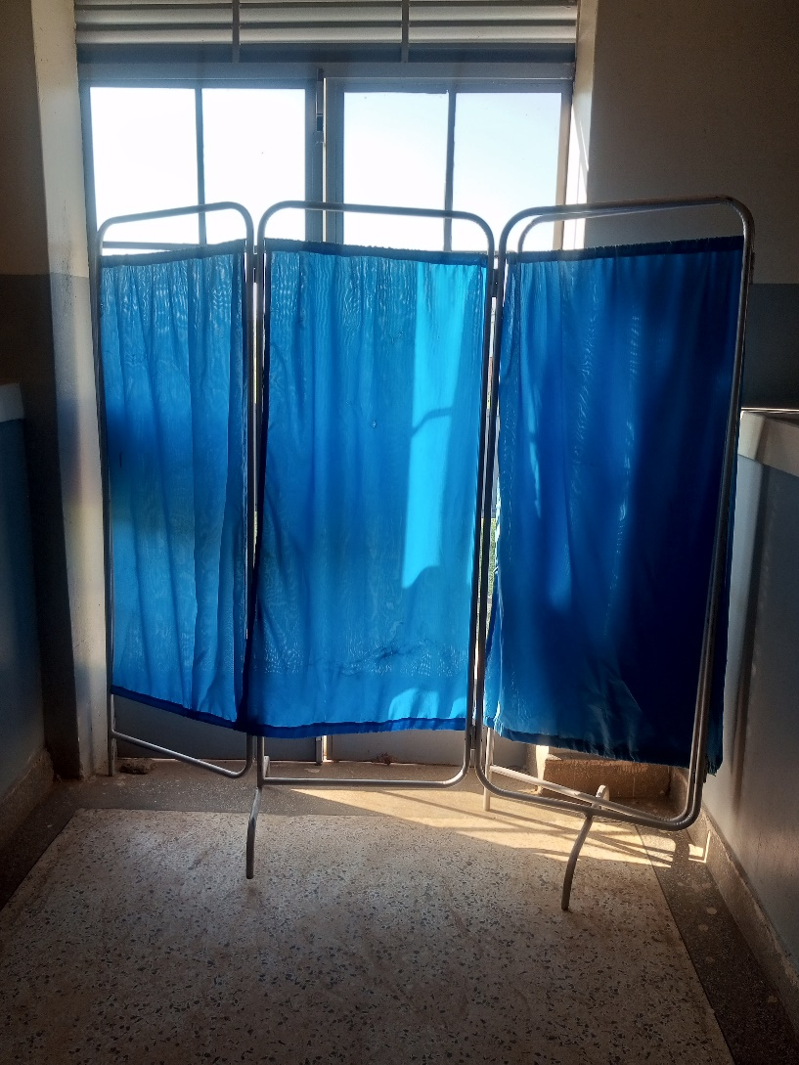
s

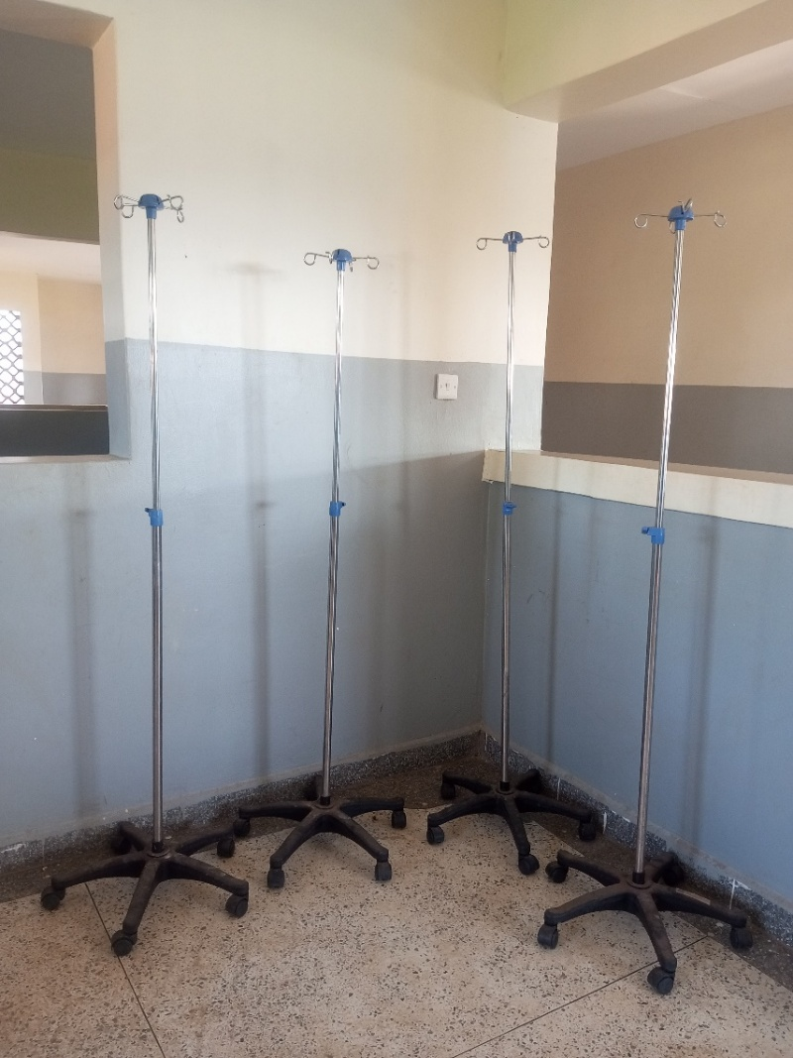

Drip stand

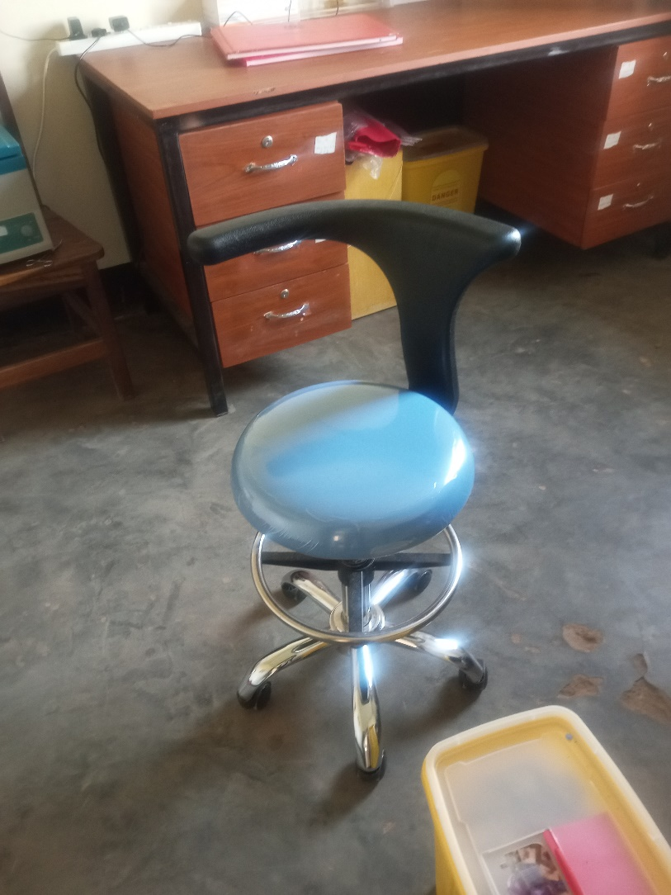

Laboratory stool

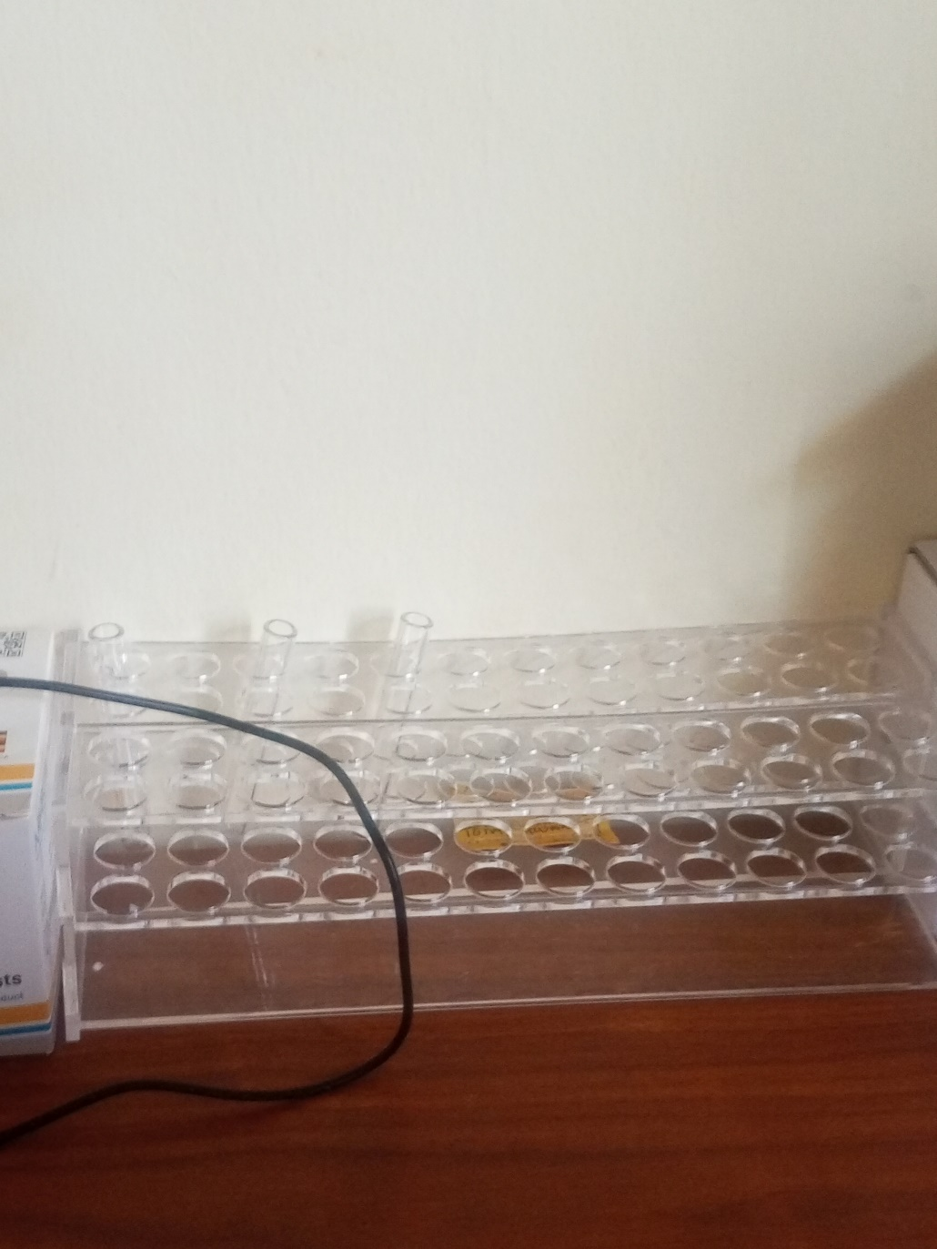

ESR Stand

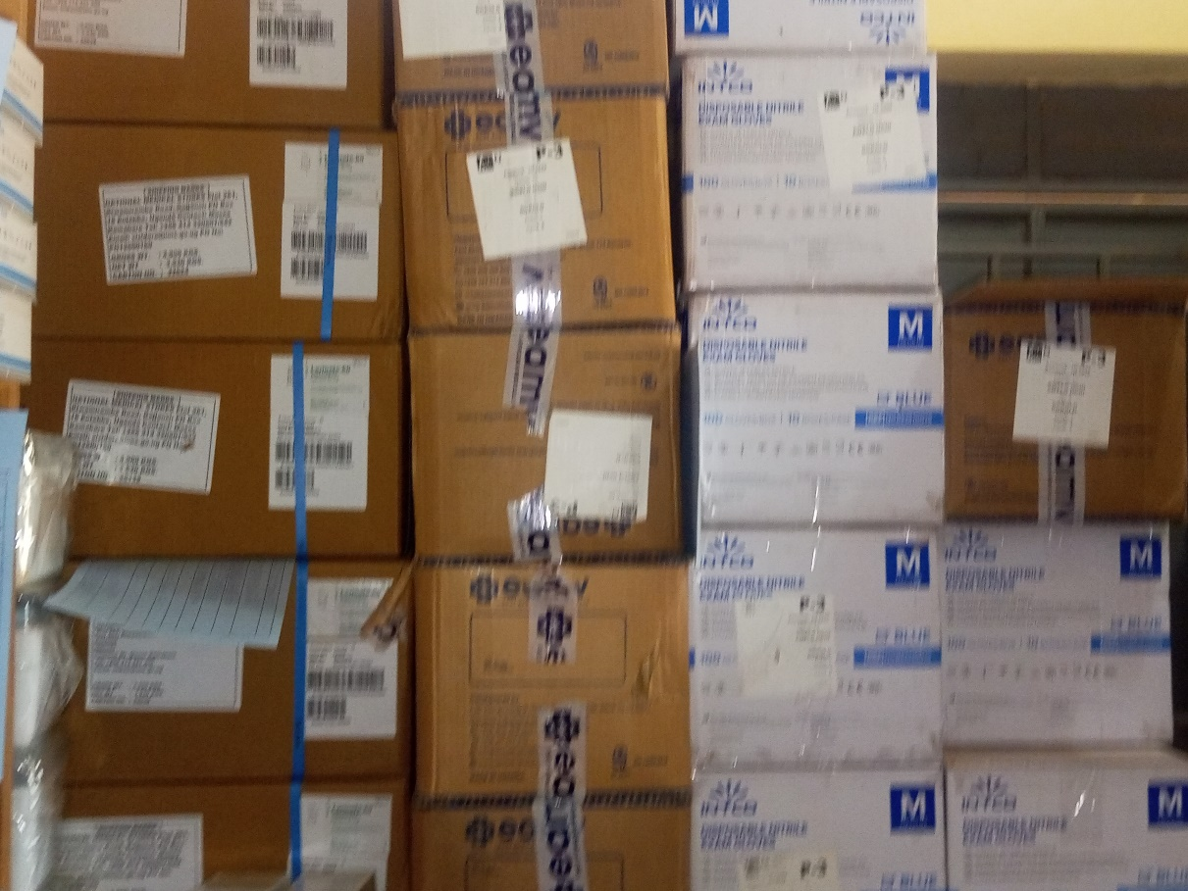

Some of the equipment in the store

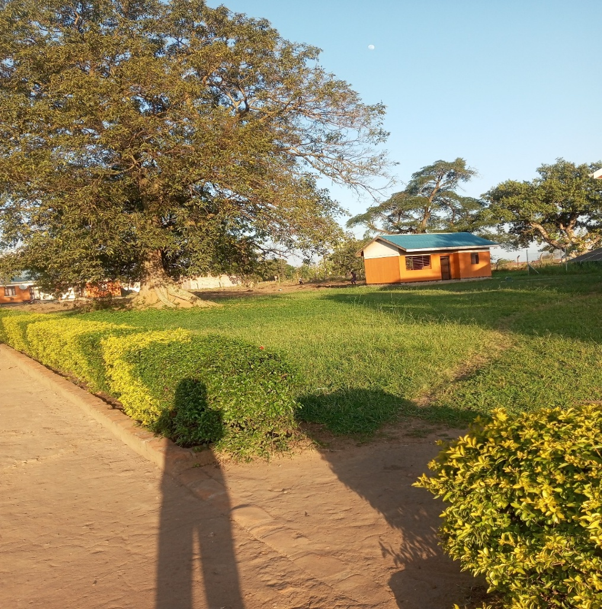

Awelo Health center kitchen

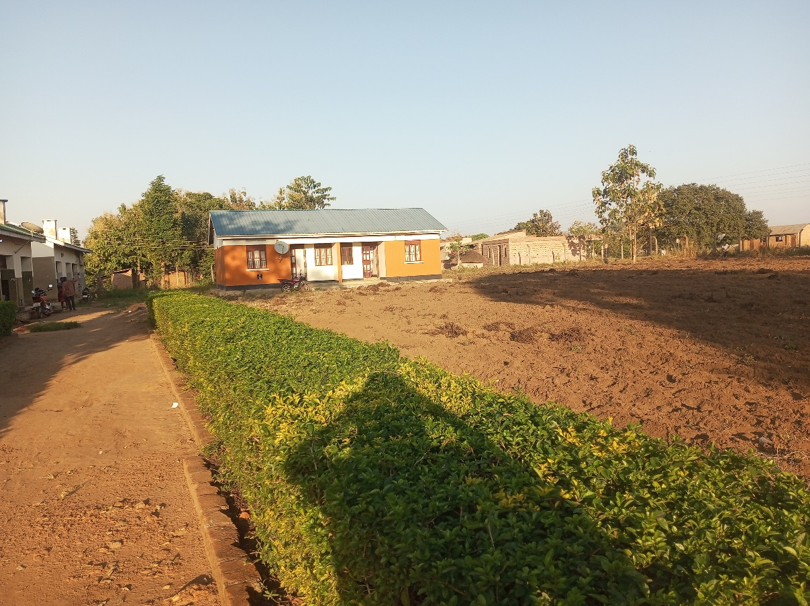

Staff twin house

MCH Ward

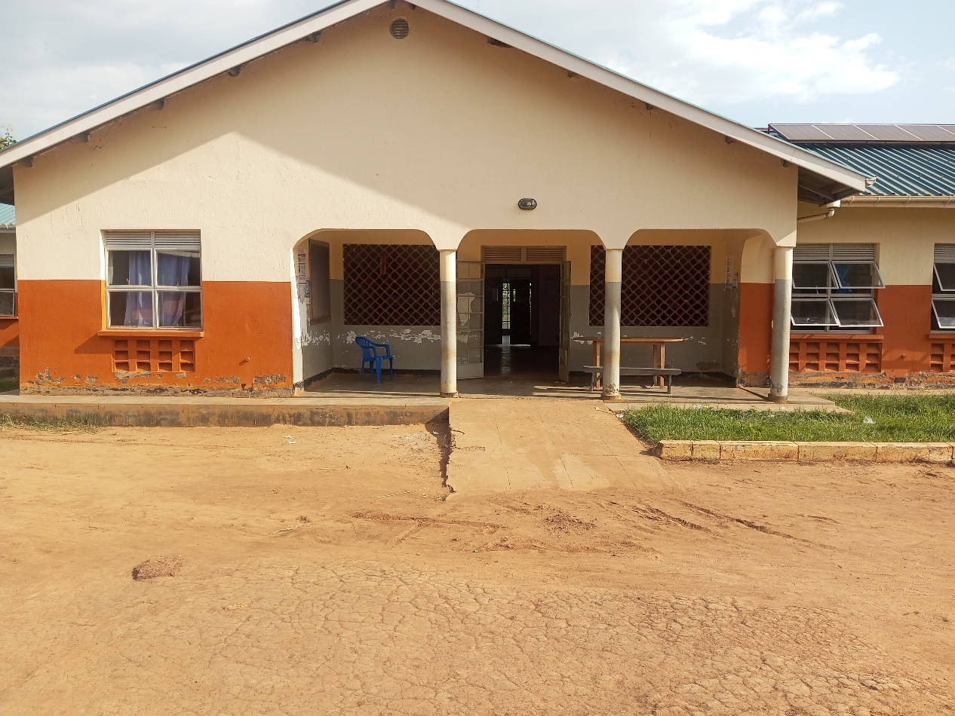

SCHOOL VERIFICATION CHECKLIST

SCHOOL INTERVIEW/DISCUSSION GUIDE

Name of school: ………………………………………………………………………………..

1a | Does the Facility have a record of all assets provided under UgIFT.  (Obtain a record and verify if it has the costs and numbers supplied
1b | If Not ask how many were supplied and when.

2 | How does this facility Maintain (repair/service/replace) the assets provided under Ugift

3 | Does the facility take regular record about functionality/ or breakdown of the assets provided?  Nonfunctional/ working, and reasons for non-functionality.

4 | How has the UgIFT support helped in service delivery in the area, any issues, challenges and any recommendations for better program implementation.

PROCEED TO VERIFICATION AFTER THIS DISCUSSION

SCHOOL FURNITURE
(School Desks, Office chairs, Laboratory stools, Book shelves)

Name of LG………………………………………………………………… Name of SCHOOL………………………………………………………………………………

Equipment/ Item | Department | Asset Number | Item  Description | Life in Months | Tag Number ( engrave no.) | Date Of Pur | Date Placed In Service | Recoverable cost | Cost | Acc Dep Cost | Net Book Value | Ytd Deprn | Equipment status | Remarks

ICT ITEMS TO VERIFY
(Desktop Computer, Server Processor, Network Switch 24 Port, Multipurpose Printer, UPS, Projector, Air Conditioners, Server, CCTV Camera)

Name of LG…………………………………………………………………………… Name of SCHOOL………………………….………………………………………

Equipment/ Item | Department | Asset Number | Item  Description | Life in Months | Tag Number ( engrave no.) | Date Of Pur | Date Placed In Service | Recoverable cost | Cost | Acc Dep Cost | Net Book Value | Ytd Deprn | Equipment status | Remarks

BUILDINGS TO VERIFY
(Non- Residential and Residential, Kitchen, Toilets/Pit latrine Water tanks, Fences etc.)

Name of LG…………………………………………………………………………… Name of SCHOOL………………………….………………………………………

Equipment/ Item | Department | Asset Number | Item  Description | Life in Months | Tag Number ( engrave no.) | Date Of Pur | Date Placed In Service | Recoverable cost | Cost | Acc Dep Cost | Net Book Value | Ytd Deprn | Equipment status | Remarks

